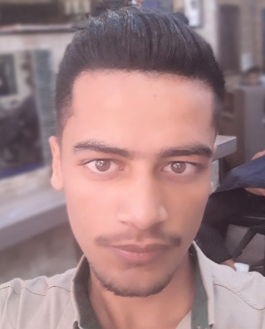

**CV**

Mustafa Mohamad ALawad

**Personal Information:**

Nationality: Syrian Data of Berth:2000/6/4

Marital Status: Single Address:Damaccus-Altbalah

Phone Number:0933519097 E-mail:Mustafa.2020sy@gmail.com

**Objective:**

I studied for three years secondary computer technology and entered the Institute of Computer Technology in Damascus, the second year software department and I was from the first province of Daraa secondary stage and succeeded at the rate of 82.74 and underwent computer maintenance courses in the form of a beginner and advanced and worked for a period of time on Word and Excel programs and now I develop my skills in programming language SEO Sharp and Web Design.

**Work Performed:**

1- Professional maintenance technician.

2 - working on programming applications in C Sharp language.

3. Working on Word and Excle programs.

4 - work on the design of websites but in a novice or medium.